**JAYPEE UNIVERSITY OF ENGINEERING AND TECHNOLOGY, GUNA**

**Data Security Lab**

**Experiment No. 1**

**IMPLEMENTATION OF CAESAR CIPHER**

**AIM:**

To implement the simple substitution technique named Caesar cipher using C language.

**DESCRIPTION:**

To encrypt a message with a Caesar cipher, each letter in the message is changed using a simple rule: shift by three. Each letter is replaced by the letter three letters ahead in the alphabet. A becomes D, B becomes E, and so on. For the last letters, we can think of alphabet as a circle and "wrap around". W becomes Z, X becomes A, Y becomes B, and Z becomes C. To change a message back, each letter is replaced by the one three before it.

**EXAMPLE:**

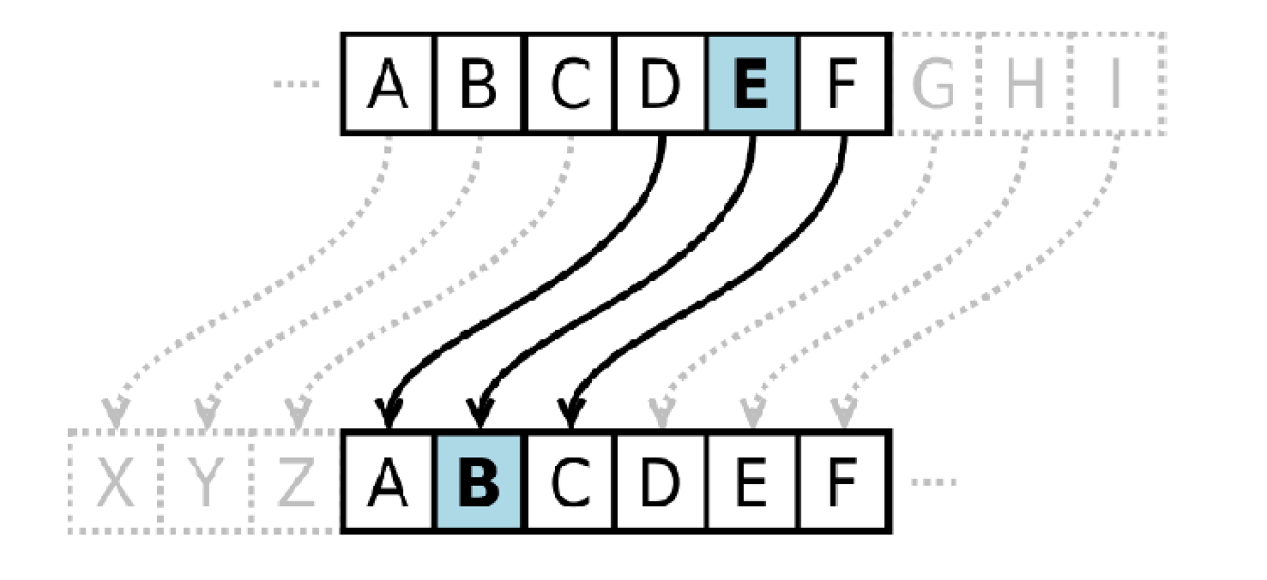

**ALGORITHM:**

**STEP-1:** Read the plain text from the user.

**STEP-2:** Read the key value from the user.

**STEP-3:** If the key is positive then encrypt the text by adding the key with each

character in the plain text.

**STEP-4:** Else subtract the key from the plain text.

**STEP-5:** Display the cipher text obtained above.